 

**A Comprehensive Guide**

**to Global Tourism and Cultural Navigation A PROJECT REPORT**

***Submitted by***

**DINESH S (927621BAD011) KAVIN K V (927621BAD021) SHARAN ADHITHYA S (927621BAD047)**

*in partial fulfilment for the award of the degree of*

### BACHELOR OF TECHNOLOGY

*in*

### ARTIFICIAL INTELLIGENCE AND DATA SCIENCE

**M.KUMARASAMY COLLEGE OF ENGINEERING, KARUR ANNA UNIVERSITY: CHENNAI 600 025**

### JUNE 2024

i

## M.KUMARASAMY COLLEGE OF ENGINEERING

**(Autonomous Institution affiliated to Anna University, Chennai)**

## KARUR – 639 113 BONAFIDE CERTIFICATE

Certified that this project report **“A Comprehensive Guide to Global Tourism and**

**Cultural Navigation”** is the bonafide work of **“DINESH S (927621BAD011), KAVIN K V (927621BAD021), SHARAN ADHITHYA S (927621BAD047)”** who carried

out the project work during the academic year 2023-24 under my supervision. Certified further, that to the best of my knowledge the work reported herein does not form part of any other project or dissertation on the basis of which a degree or award was conferred on an earlier occasion on this or any other candidate.

|  |  |
| --- | --- |
| **SIGNATURE**  Mrs. P. VIDHYA **SUPERVISOR,** ASSISTANT PEOFESSOR,  Department of Artificial Intelligence and Data Science,  M. Kumarasamy College of Engineering,  Thalavapalayam, Karur-639113. | **SIGNATURE**  Dr.R.RAJA GURU, M.Tech, Ph.D., **HEAD OF THE DEPARTMENT,** ASSOCIATE PROFESSOR,  Department of Artificial Intelligence and Data Science,  M. Kumarasamy College of Engineering,  Thalavapalayam, Karur-639113. |

### ABSTRACT

An intelligent tourist guide employs advanced technologies such as artificial intelligence and data analytics to enhance the travel experience. Utilizing location-based services, user preferences, and historical data, the system delivers personalized recommendations for attractions, dining, and activities. Real-time updates, interactive maps, and multi-modal transportation information contribute to a seamless and tailored journey, providing travelers with an intelligent and efficient guide to explore destinations. In an age where technology plays an integral role in almost every aspect of our lives, the tourism industry is no exception. The emergence of smartphones, augmented reality, and AI-powered systems has revolutionized the way people plan, experience, and document their travels. The "Travel Guide System" project seeks to harness the power of technology to provide travelers with personalized, interactive, and seamless travel experiences. This project aims to develop a comprehensive travel guide system that leverages cutting-edge technologies to offer tailored recommendations, real-time information, and immersive experiences to users. The system will be designed to cater to the diverse needs and preferences of travelers, whether they are seeking adventure, cultural immersion, relaxation, or culinary exploration. In the modern era of travel, technology has become an indispensable tool for adventurers seeking seamless and enriching experiences. The Travel Guide System project aims to revolutionize the way travelers explore and navigate destinations by harnessing the power of artificial intelligence and data analytics. This innovative system serves as a smart companion for travelers, offering personalized recommendations, real-time information, and interactive features to enhance every aspect of the journey. The project integrates various technologies to provide a comprehensive and user- friendly platform that caters to the diverse needs of travelers. However, the rapid growth of tourism has also brought about significant challenges, including environmental degradation, cultural commodification, and social inequalities. Resources and tools to help travelers minimize their environmental footprint and support local communities. Information on eco-friendly accommodations, responsible tour operators, and sustainable. Interactive maps, immersive photos, and user-generated content to enhance the travel experience. Tourist Guide seeks to address these challenges by offering a holistic approach to tourism that prioritizes sustainability, cultural tourism that enables sensitivity, and responsible travel practices.

**TABLE OF CONTENTS**

|  |  |  |
| --- | --- | --- |
| **CHAPTER No.** | **TITLE** | **PAGE No.** |
|  | ABSTRACT | iii |
|  | TABLE OF CONTENTS | iv |
|  | LIST OF FIGURES | vi |
|  | LIST OF ABBREVIATIONS | vii |
| **1** | **INTRODUCTION** | **1** |
|  | CULTURAL EXPLORATION AND TRAVEL NAVIGATION | 2 |
| **2** | **LITERATURE REVIEW** | **3** |
| **3** | **EXISTING SYSTEM** | **9** |
|  | 3.1 TRADITIONAL TRAVEL AGENCIES | 10 |
|  | 3.2 ONLINE BOOKING PLATFORMS | 10 |
|  | 3.3 CULTURAL EXCHANGE PROGRAMS | 10 |
|  | 3.4 TOURIST INFORMATION CENTRE | 11 |
|  | 3.5 CULTURAL TOURISM ORGANIZATIONS | 11 |
| **4** | **PROBLEM DESCRIPTION** | **12** |
| **5** | **PROPOSED SYSTEM** | **14** |
|  | 5.1 SYSTEM ARCHITECTURE | 15 |
|  | 5.2 CHALLENGES AND SOCIAL BENEFITS | 15 |
|  | 5.3 DISADVANTAGES | 16 |

|  |  |  |
| --- | --- | --- |
| **CHAPTER No.** | **TITLE** | **PAGE No.** |
| **6** | **IMPLEMENTATION** | **17** |
|  | 6.1 MODULES | 18 |
|  | 6.1.1 EVENTS AND PACKAGES | 19 |
| 6.1.2 MEMBER SERVICES | 19 |
| 6.1.3 USER QUERY SUPPORT | 20 |
| 6.2 IMPLEMENTATION DETAILS | 22 |
| 6.2.1 ALGORITHMIC STEPS  6.3 TOOLS USED    6.4 SOURCE CODE | 23  24  24 |
| **7** | **RESULT AND DISCUSSION** | **28** |
|  | 7.1 TESTING | 30 |
|  | 7.2 RESULTS | 29 |
|  | 7.3 HELP AND QUERY SUPPORT | 32 |
| **8** | **CONCLUSION AND FUTURE ENHANCEMENT** | **34** |
| **9** | **REFERENCES** | **37** |

**LIST OF FIGURES**

|  |  |  |
| --- | --- | --- |
| **FIGURE No.** | **TITLE** | **PAGE No.** |
| 6.1  6.2  6.3  6.4  6.5 | USER LOGIN PAGE EVENTS AND PACKAGES USER SUPPORT  USER QUERY SUPPORT  WORK FLOW | 17  18  19  20  21 |
| 7.1 | USER INTERFACE | 29 |
| 7.2 | TOUR PACKAGE LIST | 30 |
| 7.3 | HELP AND SUPPORT | 31 |
| 7.4 | QUERY SUPPORT | 32 |

**LIST OF ABBREVIATIONS**

|  |  |
| --- | --- |
| **HTML** | Hypertext Markup Language |
| **WWW** | World Wide Web |
| **CSS** | Cascading Style Sheets |
| **SQL** | Structured Query Language |
| **PHP** | Personal Home Page |
| **UX** | User Experience |
| **SOMs** | Self-Organizing Maps |
| **API** | Application Programming Interface |

# CHAPTER 1 INTRODUCTION

### ` CHAPTER 1

**INTRODUCTION**

### Introduction to Cultural Exploration and Travel Navigation

Welcome to "A Comprehensive Guide to Global Tourism and Cultural Navigation"! Within these pages lies a treasure trove of knowledge, curated to serve as your compass in navigating the rich tapestry of our planet's diverse cultures and awe-inspiring destinations. Embark on a journey of discovery as we delve into the heart of global tourism, unveiling hidden gems, unraveling the mysteries of ancient civilizations, and immersing ourselves in the vibrant tapestry of human experiences. From the towering skyscrapers of modern metropolises to the serene tranquility of remote villages, each corner of the world holds its own unique allure, waiting to be explored. But beyond the surface attractions lies a deeper, more profound connection – the shared humanity that unites us all. Through authentic cultural encounters, responsible travel practices, and a commitment to fostering mutual respect and understanding, we can bridge the gaps that divide us and forge meaningful connections with people from all walks of life. From the towering skyscrapers of modern metropolises to the serene tranquility of remote villages, each corner of the world holds its own unique allure, waiting to more profound connection. So whether you're embarking on a solo adventure, planning a family getaway, or seeking to broaden your horizons through immersive cultural exchanges, let this guide be your trusted companion on the journey of a lifetime. Join us as we embark on a quest to uncover the wonders of our world and celebrate the boundless diversity that makes travel such a transformative and enriching experience. These sources typically include travel websites, guidebooks, travel agencies, online forums, and social media platforms. Clean and intuitive dashboard layout with widgets for quick insights. While these resources offer valuable insights into destinations, attractions, and travel tips, they often lack comprehensive coverage, cultural sensitivity, and sustainability considerations. Embark on a journey of discovery as we delve into the heart of global tourism, unveiling hidden gems, unraveling the mysteries of ancient civilizations, and immersing ourselves in the vibrant tapestry of human experiences. From the towering skyscrapers of modern metropolises to the serene tranquility of remote villages, each corner of the world holds its own unique allure, waiting to more profound connection.

# CHAPTER 2 LITERATURE REVIEW

### CHAPTER 2 LITERATURE REVIEW

In the Review on “A Comprehensive Guide to Global Tourism and Cultural Navigation”: The evolution of technology has significantly transformed the way we travel, with digital tools playing an increasingly vital role in trip planning and navigation. Travel guide systems leverage technology to provide travelers with personalized recommendations, real-time information, and interactive experiences. This literature review aims to explore the existing research and developments in the field of travel guide systems, highlighting key trends, challenges, and opportunities. Early travel guide systems were primarily print-based, such as guidebooks and maps, offering static information and limited interactivity. The advent of the internet and mobile technology revolutionized travel guides, enabling dynamic content delivery, user-generated reviews, and location-based services. Recent advancements in artificial intelligence (AI), machine learning, and natural language processing have further enhanced the capabilities of travel guide systems, allowing for personalized recommendations and intelligent conversational interfaces. Research has emphasized the importance of user experience (UX) design in travel guide systems, focusing on intuitive interfaces, engaging content presentation, and seamless navigation. Personalization algorithms analyze user preferences, behavior, and contextual factors to deliver tailored recommendations, enhancing relevance and satisfaction. Social media integration enables travelers to share experiences, recommendations, and photos with their social networks, fostering community engagement and facilitating peer-to-peer communication. Collaborative filtering techniques leverage collective user data to generate personalized recommendations based on similar travelers' preferences and behavior. Resources and tools to help travelers minimize their environmental footprint and support local communities. Information on eco-friendly accommodations, responsible tour operators, and sustainable transportation options. Packing lists, travel insurance recommendations, and safety tips to ensure a smooth and hassle-free journey. Integration with booking platforms and travel agencies for seamless trip planning. A curated collection of destination guides highlighting both popular tourist attractions and off-the-beaten-path gems. In-depth information on historical landmarks, cultural festivals, culinary traditions, and local customs. Interactive maps, immersive photos, and user-generated content to enhance.

**TABLE 2.1 LITERATURE REVIEW**

|  |  |  |  |  |
| --- | --- | --- | --- | --- |
| **S.NO** | **YEAR** | **PAPER TITLE** | **AUTHOR NAME** | **METHODOLOGY USED** |
| 1 | 2019 | An Overview of Tour-Guide Training Literature in Türkiye | Aslan & Büyükkuru; Çokişler; Eser; Topsakal; Çokişler | Tour guiding, training |
| 2 | 2016 | Survey on context-aware tour guide systems | Hamed Vahdat-Nejad , Hossein Khosravi-Mahmouei , Mohammad Ghanei-Ostad, Azam Ramazani | It fulfil the smartness of the infrastructure to provide intelligent personalizes |
| 3 | 2011 | Intelligent mobile tourist guide | Smirnov, A., Kashevnik, A., Balandin, S.I | Next Generation Wired/Wireless Advanced Networking |
| 4 | 2018 | A location aware mobile tourist guide | Ten Hagen, K., Modsching, M., Kramer, R | Selecting and interpreting sights and services by context matching |
| 5 | 2019 | Tourism and mobile technology | Brown, B., Chalmers, M | Automatic construction of travel itineraries using social breadcrumbs |
| 6 | 2020 | Context-aware recommendations in the mobile tourist application COMPASS | Van Setten, M., Pokraev, S., Koolwaaij, J | A system for mining interesting tourist locations and travel sequences from public geo-tagged photos |
| 7 | 2022 | Smart tourism destinations | Buhalis, D., Amaranggana | Information and communication technologies in tourism |
| 8 | 2009 | Research Design of Intelligent Tourist Guide System and Development | Kaijian Huang1, a and Junwu Zhu | Intelligent Tourist Guide System; Shortest Path Algorithm; Android |
| 9 | 2019 | A Model for Intelligent Tourism Guide System | H.H. Owaied, H.A. Farhan, N. Al-Hawamdeh | System can provide the relevant service of the spot more accurately for the visitors |
| 10 | 2009 | A systematic literature review for the tourist trip design problem: Extensions, solution techniques and future research lines | Jos´e Ruiz-Meza, Jairo R. Montoya-Torres | Trend of personalized tourism, which includes management of itineraries by the tourist |
| 11 | 2011 | A Systematic Literature Review of Tour Guide Performance | Marceilla Suryana | To be related to tourist satisfaction, tourist experience, behavior in the destination and the desire to revisit the people |
| 12 | 2019 | Tour Guide Performances, Tourist Satisfaction And Behavioural Intentions | Syakier, W. A., & Hanafiah, M. H. | A Study On Tours In Kuala Lumpur City Centre. Journal of Quality Assurance in Hospitality and Tourism |
| 13 | 2009 | Tour guides’ performance and tourists’ immersion | Hansen, A. H., & Mossberg, L | Facilitating consumer immersion by performing a guide plus role. Scandinavian Journal of Hospitality and Tourism |
| 14 | 2022 | Virtual Tourist Guide | Shila Jawale , Sakshi Jadhav, Priyanka Jaybhaye , Nikita Sonavale | Virtual Tour, Android Based Guide Application, G-map |
| 15 | 2020 | Virtual Reality Based Virtual Tour of College Using Unity 3D | Chaisoong, U., & Tirakoat, S | The proposed system virtual tour of college specifically on Unity3D which provides virtual view of college infrastructure |
| 16 | 2013 | Design and Implementation of Threedimensional Virtual Tour Guide Training System Based on Unity3D | Burta, A., Szabo, R., & Gontean | Provides a training environment with strong interactivity and immersion for enabling them to "go to" the scenic spot |
| 17 | 2016 | Tourism Guide Application(Gujarat State) | Yogendra Singh Chawda | To provide a search platform where a tourist can find their tour places according to their choices. |
| 18 | 2017 | Tour Guide Performances, Tourist Satisfaction And Behavioural Intentions | Syakier, W. A., & Hanafiah, M. H | A Study On Tours In Kuala Lumpur City Centre. Journal of Quality Assurance in Hospitality and Tourism from Globally |
| 19 | 2020 | Tour guides’ performance and tourists’ immersion | Hansen, A. H., & Mossberg, L | Facilitating consumer immersion by performing a guide plus role. |
| 20 | 2016 | Virtual Reality Based Virtual Tour of College Using Unity 3D | Chaisoong U & Tirakoat S | The proposed system virtual tour of college specifically on Unity3D which provides virtual view of college infrastructure |
| 18 | 2019 | An innovative mobile electronic tourist guide application1 | M. Kenteris, D. Gavalas and D. Economou | To promote responsible and interesting tourism so that people can enjoy their holidays at their places where they want to visit |
| 19 | 2010 | A multiplatform mobile application tourist guide exemplar | M. Kenteris, D. Gavalas and D. Economou | To develop tourism with different cultures so that they enrich the tourism experience and build pride. |
| 20 | 2019 | Go.Travel – A Smart Tourism Guide Mobile Application | Wong Yit Meng, Abdul Samad Bin Shibghatullah, Kasthuri Subaramaniam | This enables visitors to Malaysia to take advantage of tourism-related services to enhance their travels through world wide |
| 21 | 2017 | Context-aware recommendations in the mobile tourist application Compass | Van Setten, M.,  Pokraev, S.,  Koolwaaij, J | A system for mining interesting tourist  locations and travel sequences from  public geo-tagged photos |
| 22 | 2019 | Research Design of Intelligent Tourist Guide System and Development | Kaijian  Huang1, a and  Junwu Zhu | Intelligent Tourist Guide System; Shortest Path Algorithm; Android |
| 23 | 2019 | Intelligent mobile tourist guide | Smirnov, A., Kashevnik, A., Balandin, S.I | Discussion on integration of Next Generation Wired/Wireless Advanced Networking |
| 24 | 2018 | Smart tourism destinations | Buhalis, D., Amaranggana | Information and communication technologies in tourism |

# CHAPTER 3 EXISTING SYSTEM

### CHAPTER 3 EXISTING SYSTEM

* 1. **Traditional Travel Agencies:**

Traditional travel agencies have long been the cornerstone of travel planning, offering services ranging from booking flights and accommodations to organizing guided tours. While they provide personalized assistance and expertise, their reliance on offline channels and standardized packages may limit flexibility and customization for travelers seeking unique cultural experiences. Travel websites such as TripAdvisor, Lonely Planet, and Expedia provide extensive information on destinations, accommodations, and activities. Guidebooks offer curated recommendations and travel advice for popular destinations. However, while these resources offer valuable insights, they often lack a cohesive and integrated approach to addressing the complexities of global tourism, such as cultural sensitivity, sustainability, and responsible travel practices.

### Online Booking Platforms:

Online booking platforms have revolutionized the way travelers research, plan, and book their trips, offering convenience and accessibility at their fingertips. Platforms like Booking.com, Airbnb, and Expedia provide a vast array of options for accommodations, activities, and transportation, empowering travelers to tailor their itineraries to their preferences. However, the abundance of choices can be overwhelming, and the lack of direct human interaction may detract from the cultural immersion experience. Travel agencies offer personalized trip planning services and curated tour packages. Online forums and social media platforms like Reddit, TripAdvisor forums, and Facebook travel groups allow travelers to seek advice, share experiences, and connect with fellow enthusiasts.

### Cultural Exchange Programs:

Cultural exchange programs facilitate meaningful interactions between travelers and local communities, promoting cross-cultural understanding and mutual learning. Organizations like Couchsurfing, Workaway connect travelers with hosts worldwide, offering opportunities to stay with locals, participate in cultural activities, and contribute to community projects. These programs foster authentic cultural experiences and foster long-lasting connections, open and adaptability from participants. Cultural and environmental organizations may offer educational resources and initiatives to promote responsible tourism and cultural preservation. Government tourism websites provide information on attractions, events, and travel regulations.

### Tourist Information Centers:

Tourist information centers serve as valuable resources for travelers seeking guidance and information about local attractions, events, and services. Staffed by knowledgeable professionals, these centers provide maps, brochures, and recommendations to help visitors navigate their destinations effectively. While they offer localized expertise and support, their availability and accessibility may vary depending on the destination's infrastructure and resources. In the existing system of global tourism, travelers typically rely on a variety of sources for information and guidance when planning their trips. These sources include travel websites, guidebooks, travel agencies, online forums, and social media platforms. While these resources offer valuable insights into destinations, accommodations, and activities, they often lack comprehensive coverage, cultural sensitivity, and sustainability considerations. Travel websites and guidebooks may prioritize tourist hotspots over lesser-known attractions and may overlook cultural nuances and sustainability concerns. Travel agencies offer personalized trip planning services but may not always prioritize cultural immersion or authentic local experiences. Overall, the existing system provides a wealth of information but lacks a cohesive and integrated approach to addressing the complexities of global tourism, emphasizing the need for a more comprehensive and user-centric solution.

### Cultural Tourism Organizations:

Cultural tourism organizations play a vital role in promoting and preserving cultural heritage sites, traditions, and practices. Entities like UNESCO, National Geographic, and local heritage foundations advocate for sustainable tourism practices, heritage conservation, and community empowerment. Through educational initiatives, advocacy campaigns, and destination management efforts, these organizations contribute to the enrichment and sustainability of cultural tourism experiences worldwide. Online forums and social media platforms provide peer-to-peer recommendations but may lack curated content and reliable information. Cultural and environmental organizations may offer educational resources and initiatives, but these efforts may not always reach mainstream travelers. Overall, the existing system provides a wealth of information but lacks a cohesive and integrated approach to addressing the complexities of global tourism, emphasizing the need for a more comprehensive and user-centric solution. Travel websites and guidebooks may prioritize tourist hotspots over lesser-known attractions and may overlook cultural nuances and sustainability concerns. Travel agencies offer personalized trip planning services but may not always prioritize cultural immersion or authentic local experiences. Cultural and environmental organizations may offer educational resources and initiatives

# CHAPTER 4 PROBLEM DESCRIPTION

### CHAPTER 4 PROBLEM DESCRIPTION

#### PROBLEM DESCRIPTION

Traveling the world and immersing oneself in diverse cultures is a dream for many, but it comes with its set of challenges. Understanding these challenges is crucial for travelers to navigate unfamiliar territories effectively while respecting local customs and traditions. One of the primary challenges in global tourism is cultural sensitivity. Every culture has its own norms, values, and taboos, and travelers must be mindful of these to avoid unintentionally causing offense or discomfort. From dress codes to social etiquette, cultural sensitivity plays a vital role in fostering positive interactions and building bridges across cultural divides. Another challenge is the preservation of cultural heritage in the face of increasing tourism. As more travelers visit popular destinations, the risk of overtourism and cultural commodification grows. Balancing the economic benefits of tourism with the need to authenticity is a delicate task that requires collaboration between stakeholders, including governments, local communities, and the tourism industry. Tourism often exacerbates existing inequalities and inequities, with marginalized communities and indigenous peoples bearing the brunt of negative impacts while reaping few benefits. Economic disparities, land displacement, and cultural commodification can result in social tensions, exploitation, and loss of cultural identity among local populations. Despite growing awareness of sustainability and responsible tourism, many travelers and tourism businesses continue to prioritize short-term gains over long-term sustainability and ethical considerations. This perpetuates patterns of conflicts, and negative experiences for both travelers and locals, exploitation, environmental degradation, and cultural appropriation, undermining the positive potential of tourism as a force for mutual understanding and positive change. With a plethora of travel websites, guidebooks, and online resources available, travelers often struggle to find reliable, relevant, and up-to-date information to plan their trips effectively. Overtourism in popular destinations leads to overcrowding, pollution, habitat destruction, and strain on infrastructure.

# CHAPTER 5 PROPOSED SYSTEM

### CHAPTER 5 PROPOSED SYSTEM

* 1. **System Architecture**

The architecture of our comprehensive guide to global tourism and cultural navigation comprises various components aimed at enriching travelers' experiences and fostering cultural understanding. It includes an intuitive user interface accessible through web platforms and mobile applications. The guide integrates interactive maps, cultural databases, and personalized recommendations to facilitate seamless navigation through diverse cultural landscapes. Augmented reality features allow travelers to virtually explore historical sites, museums, and cultural landmarks, enhancing their immersion in local traditions and customs.

### Challenges and Social Benefits

#### Challenges:

Developing an alcoholic detection system entails various challenges that must be addressed for successful implementation:

* **Cultural Sensitivity:** Ensuring that the guide respects diverse cultural norms, values, and sensitivities poses a significant challenge. Cultural sensitivity training for content creators and continuous feedback mechanisms from local communities are essential to address this challenge. Tourism often exacerbates existing inequalities and inequities, with marginalized communities and indigenous peoples bearing the brunt of negative impacts while reaping few benefits.
* **Technological Accessibility:** Bridging the digital divide and ensuring that the guide is accessible to travelers from diverse backgrounds, conflicts, and negative experiences for both travelers and locals, including those with limited technological literacy or access to digital devices, requires innovative solutions such as offline modes and multilingual support.
* **Ethical Considerations:** Addressing ethical concerns related to cultural representation, authenticity, and intellectual property rights is paramount. Collaborating with local stakeholders and adhering to ethical guidelines for content creation and dissemination are essential to uphold ethical standards.

#### Social Benefits:

Implementing "A Comprehensive Guide to Global Tourism and Cultural Navigation" offers numerous social benefits:

* **Enhanced Cultural Understanding:** he guide promotes deeper insights into diverse cultures and traditions, fostering empathy, understanding, and respect among travelers.
* **Empowering Local Communities:** By showcasing local cultural assets and promoting community-led tourism initiatives, the guide empowers local communities to share their heritage and benefit from tourism in a sustainable manner.
* **Fostering Intercultural Dialogue:** The guide facilitates interactions between travelers and local communities, promoting intercultural dialogue and mutual learning.
* **Promoting Responsible Tourism:** By encouraging responsible travel behavior and promoting ethical cultural exploration practices, the guide contributes to sustainable tourism development and cultural preservation efforts.

### DISADVANTAGES

* **Technological Dependency:** The guide's reliance on technology may pose challenges in regions with limited internet connectivity or infrastructure, limiting its accessibility to certain populations. With a plethora of travel resources available, travelers may struggle to find reliable, relevant, and up-to-date information. Navigating through the abundance of information can be overwhelming and time-consuming, leading to decision paralysis and suboptimal travel experiences.
* **Cultural Oversimplification:** There is a risk of oversimplifying complex cultural narratives and reducing diverse cultures to stereotypes or clichés, undermining the guide's effectiveness in promoting cultural understanding. This can result in strained interactions, cultural misunderstandings, and negative experiences for both travelers and locals.
* **Privacy Concerns:** Collecting and disseminating user data raises privacy concerns, necessitating robust data protection measures and transparent privacy policies to safeguard users' personal information.
* **Digital Divide:** The digital nature of the guide may exclude travelers who lack access to digital devices or technological literacy, exacerbating inequalities in cultural exploration opportunities.

# CHAPTER 6 IMPLEMENTATION

### CHAPTER 6 IMPLEMENTATION

**6.1 Modules**

Engaging hero section with stunning images showcasing diverse destinations. Clear navigation menu highlighting key sections and featured content. Dynamic sections for latest events, top destinations, and member spotlights. Supports destination management organizations and local authorities in managing tourism responsibly. Focuses on building capacity, fostering cultural competence, and promoting responsible tourism practices. Provides tools for monitoring visitor flows, environmental impacts, and community feedback. Includes strategies for destination diversification, capacity management, and sustainable tourism planning. Offers training programs and workshops for tourism stakeholders, including tour guides, hospitality staff, and local communities.

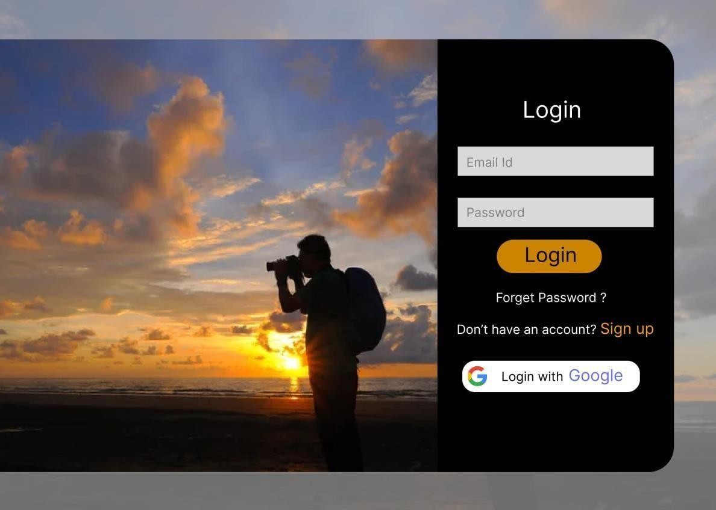

#### Fig 6.1. User-Login Page

* + 1. **Events and Packages:**

Calendar layout with color-coded events for easy identification. Filter options by date, location, and event type for personalized browsing. Integration with other scheduling tools for event reminders. Clean and visually appealing layout for easy readability. Grid or list view options for browsing articles and guides. Social sharing buttons and comment section for user engagement.

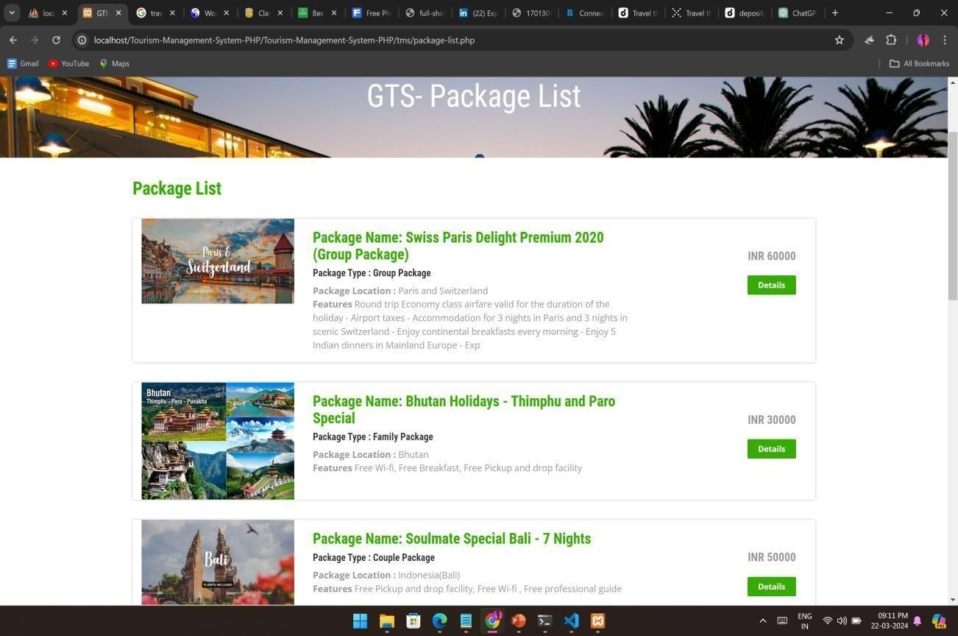

#### Fig 6.2. Events and Packages

* + 1. **Member Services:**

User-friendly registration form with clear instructions and required fields. Personalized member dashboard displaying benefits, upcoming events, and exclusive content. Integration with payment gateways for membership fees and renewals. Access to special discounts, offers, and promotions from partner organizations, hotels, airlines, and tour operators. Exclusive deals on travel packages, accommodations, and attractions for members. Personalized dashboard for each member to manage their account, preferences, and membership status. Access to exclusive content, resources, and events based on membership level.

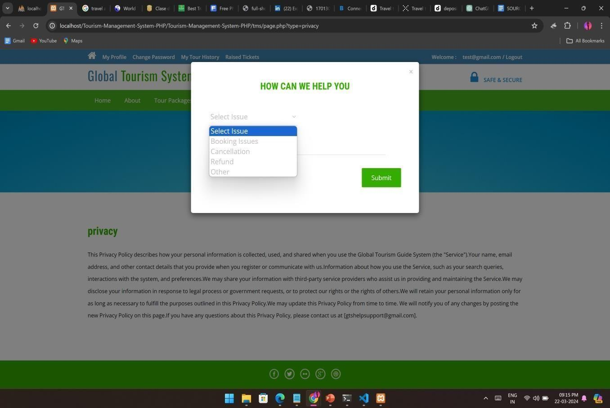

#### Fig 6.3. User Support

* + 1. **User Query Support:**

Assist users with account registration, login issues, and password resets. Monitor user activity and address any violations of website policies or terms of service. Provide guidance on updating user profiles, preferences, and notifications. Automated system for categorizing and prioritizing user queries based on their urgency, complexity, and topic. Tags or labels to classify queries into different categories such as booking assistance, destination recommendations, membership inquiries, etc. Defined workflow for escalating queries to higher-level support staff or management for resolution. Criteria for prioritizing urgent queries and ensuring timely resolution of user issues. Ticketing system for logging and tracking user queries, ensuring accountability and transparency in query resolution. Unique ticket numbers, timestamps, and status updates to keep users about the progress of their queries.

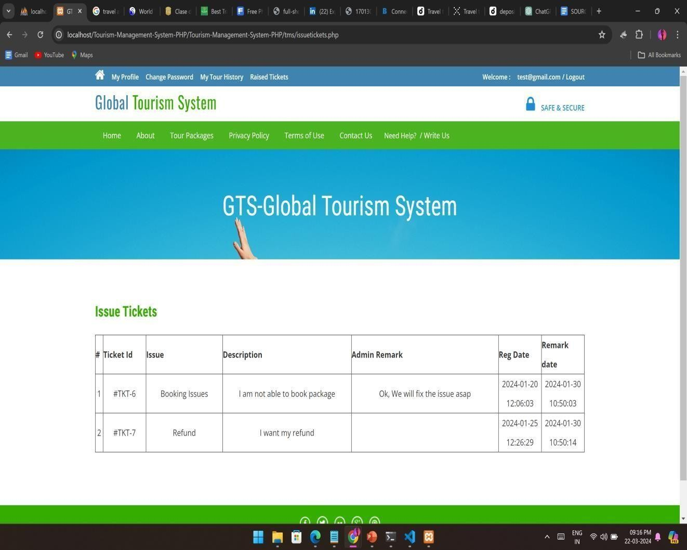

**Fig 6.4: User Query Support**

Clean and intuitive dashboard layout with widgets for quick insights. Tabbed navigation for easy access to different sections such as content management, user management, and analytics. Bulk editing and uploading options for efficient content management. Enhances user satisfaction and trust by providing timely and helpful assistance with their queries and concerns. Improves user engagement and retention by offering responsive and personalized support services. Reduces the workload on support staff by automating query management and providing self-service options through the knowledge base. Enables the tourism guild or platform to identify common user pain points and areas for improvement in service delivery. Mechanism for collecting feedback from users about their support experience, including satisfaction surveys and ratings. Continuous improvement based on user feedback to enhance the effectiveness experience and quality of query supports and services.

#### Implementation Details

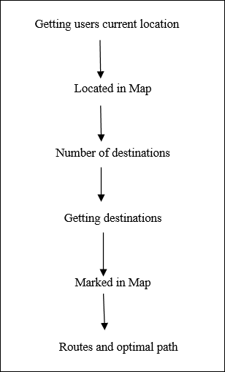

**Fig 6.5: Work Flow**

#### Algorithmic Steps:

The overall algorithm is pretty straightforward one. Clearly define the objectives, goals, and scope of the project.

* + Determine what specific features and functionalities will be included in the algorithm. Gather data on global tourism destinations, cultural practices, attractions, events, and travel-related information. Utilize reputable sources such as travel guides, government websites, cultural organizations, and academic research.
  + Develop an algorithm that provides cultural sensitivity training to travelers. Identify key cultural aspects relevant to different destinations. Create a framework for educating travelers on cultural norms, etiquette, traditions, and taboos. Provide practical tips and guidelines for respectful behavior and interaction with locals.
  + Design an algorithm to showcase destination spotlights. Organize information on popular and off-the- beaten-path destinations. Include historical background, cultural highlights, attractions, festivals, cuisine, and local customs for each destination, the algorithm may recommend actions for manual follow-up by support staff.. Implement search and filtering functionality for users to discover destinations based on their preferences.
  + Develop an algorithm focused on sustainable tourism practices. Highlight environmental conservation efforts, responsible tourism initiatives, and community-based tourism projects. Provide tips and guidelines for minimizing environmental impact, supporting local economies, and respecting indigenous cultures.
  + Create an algorithm to offer practical advice and resources for travelers. Cover topics such as budgeting, packing tips, transportation options, accommodation recommendations, and safety precautions. Additionally, it may trigger actions based on feedback, such as escalating unresolved issues or implementing process improvements.
  + This algorithm manages the lifecycle of user queries within the ticketing system. It assigns unique ticket IDs to each query, logs query details, and tracks the status of query resolution efforts. It may include functions for creating new tickets, updating ticket status, assigning tickets to support staff, and closing tickets upon resolution. Additionally, it may trigger notifications to users.

#### 6.3 Tools Used

**Programming Languages:**

Front-end: HTML, CSS, JavaScript Back-end: PHP, Node.js, Java

#### Frameworks and Libraries:

Front-end: React.js, AngularJS, Vue.js

Back-end: Express.js (Node.js), Spring Boot (Java)

#### Database Management Systems:

Relational databases: MySQL, PostgreSQL, SQLite

#### APIs and Web Services:

Integration with third-party APIs for features like mapping (Google Maps API, Mapbox), weather information (OpenWeatherMap API), flight booking (Amadeus, Skyscanner), and hotel reservations (Booking.com, Airbnb).

#### Source Code

**HTML:**

<!DOCTYPE html>

<html lang="en">

<head>

<meta charset="UTF-8">

<meta name="viewport" content="width=device-width, initial-scale=1.0">

<title>Travel Guide System</title>

<link rel="stylesheet" href="styles.css">

</head>

<body>

<!-- Header Section -->

<header>

<h1>Travel Guide System</h1>

<!-- Navigation Links -->

<nav>

<ul>

<li><a href="index.html">Home</a></li>

<li><a href="destinations.php">Destinations</a></li>

<li><a href="about.html">About Us</a></li>

</ul>

</nav>

</header>

<!-- Main Content Section -->

<main>

<h2>Welcome to our Travel Guide System</h2>

<p>Explore our destinations and plan your next adventure!</p>

<li><a href="index.html">Home</a></li>

<li><a href="destinations.php">Destinations</a></li>

<li><a href="about.html">About Us</a></li>

</ul>

</nav>

</main>

<!-- Footer Section -->

<footer>

<p>&copy; 2024 Travel Guide System. All rights reserved.</p>

</footer>

</body>

</html>

#### PHP:

<?php

// Database Connection

$servername = "localhost";

$username = "username";

$password = "password";

$dbname = "travel_guide";

$conn = new mysqli($servername, $username, $password, $dbname);

if ($conn->connect_error) {

die("Connection failed: " . $conn->connect_error);

}

$sql = "SELECT * FROM destinations";

$result = $conn->query($sql);

if ($result->num_rows > 0) { while($row = $result->fetch_assoc()) {

echo "<h2>" . $row["destination_name"]. "</h2>"; echo "<p>" . $row["description"]. "</p>";

$conn = new mysqli($servername, $username, $password, $dbname);

if ($conn->connect_error) {

die("Connection failed: " . $conn->connect_error);

}

} else {

echo "0 results";

}

$conn->close();

?>

**CSS:**

/* Global Styles */ body {

font-family: Arial, sans-serif; margin: 0;

padding: 0;

}

header, main, footer { width: 80%;

margin: 0 auto;

padding: 20px 0;

}

header {

text-align: center; background-color: #f2f2f2;

}

nav ul {

list-style-type: none;

}

nav ul li { display: inline;

margin-right: 20px;

}

nav ul li a {

text-decoration: none; color: #333;

}

main {

text-align: center;

}

footer {

text-align: center; background-color: #333; color: #fff;

padding: 10px 0;

}

# CHAPTER 7 RESULTS AND DISCUSSION

### CHAPTER 7 RESULTS AND DISCUSSION

* 1. **Testing**

**Functionality Testing:** Ensure that all links, buttons, forms, and interactive work as intended. Test the search functionality to ensure users can find destinations, accommodations, and activities easily. Verify that the homepage loads correctly and displays relevant content. Test navigation links to ensure they lead to the correct pages. Check that any dynamic elements, such as featured destinations or events, are displayed accurately. Test the search functionality to ensure users can find destinations by keywords, regions, or categories. Verify that users can register, login, and logout successfully.

**Compatibility Testing:** Test the website on different web browsers (Chrome, Firefox, Safari, Edge, etc.) to ensure compatibility. Test on different devices (desktop, laptop, tablet, smartphone) to ensure responsiveness and proper display. Test the website or application on various devices, including desktops, laptops, tablets, and smartphones. Verify that the layout, design, and user interface are responsive and adapt well to different screen sizes and resolutions.

**Performance Testing:** Check the loading speed of the website pages to ensure they load quickly. Test the website's performance under various network conditions (fast, slow, and unstable connections). Test the system's performance beyond its normal capacity by gradually increasing the load until it reaches its breaking point. Identify bottlenecks, points of failure, and performance degradation under extreme load conditions.

**Content Testing:** Verify that all content, including destination descriptions, travel tips, and cultural information, is accurate and up to date. Check for spelling and grammar errors. erify that destination pages include comprehensive information about attractions, activities, accommodations, dining options, transportation, and local culture.

**Security Testing:** Test for vulnerabilities such as SQL injection, cross-site scripting (XSS), and session hijacking. Ensure that user data (such as passwords and personal information) is securely stored. Verify that user authentication mechanisms, such as login forms and password reset functionalities, are secure and resistant to common attacks such as brute force and credential stuffing.

### Results

#### Enhanced User Experience:

Travelers benefit from a more seamless and enjoyable trip-planning experience. They can access comprehensive information about destinations, attractions, accommodations, and activities, allowing them to make more informed decisions. Implement algorithms to provide personalized recommendations for destinations, events, and activities based on user preferences, browsing history, and location. Offer customized travel itineraries and suggestions tailored to the user's interests, budget, and travel style. Optimize page loading times and performance to ensure that users can access content quickly and efficiently, even on slow network connections. Minimize unnecessary animations, scripts, and external dependencies that may slow down page loading times.

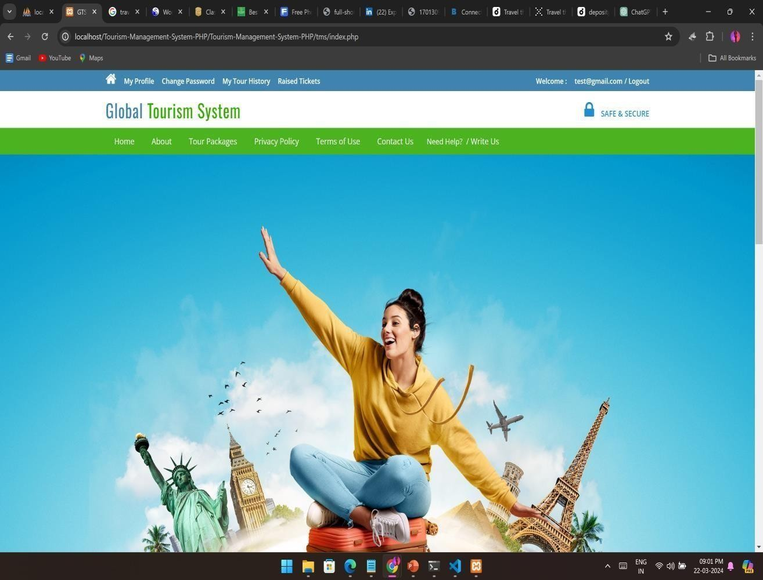

#### Fig 7.1: User Interface

**Increased Tourism Packages:**

By providing detailed information about various destinations and attractions, the tourism guide system can attract more visitors to different locations. This increased footfall can lead to higher revenue for local businesses, hotels, restaurants, and tour operators. Expand the range of destinations covered by the tourist guide system to include a diverse selection of regions, cities, and attractions. Partner with local tourism boards, tour operators, and accommodation providers to offer comprehensive packages for both popular and off-the-beaten-path destinations. Introduce themed travel packages catering to specific interests and niches such as adventure travel, culinary tourism, cultural immersion, eco-tourism, and wellness retreats. Collaborate with experts, influencers, and enthusiasts in various fields to curate unique and memorable travel experiences tailored to specific themes. Offer packages centered around major events, holidays, and celebrations to capitalize on increased demand during peak travel periods. Create seasonal packages tailored to different times of the year, highlighting activities, festivals, and events that are specific to each season.



**Fig 7.2: Tour Package List**

### Help and Query Support

#### Technical Support:

Troubleshoot technical issues related to website functionality, navigation, and accessibility. Coordinate with web developers and IT support to resolve backend issues, optimize performance, and implement updates or enhancements. Offer guidance on using website features, such as search filters, interactive maps, and booking tools. Implement a live chat support system to offer real-time assistance to users who require immediate help or have specific inquiries. Employ knowledgeable support agents who can answer questions, troubleshoot technical issues, and provide personalized assistance to users. Offer email support services to allow users to submit queries, report issues, or request assistance at their convenience. Provide prompt and professional responses to user emails, addressing their concerns and resolving their issues in a timely manner. Implement a ticketing system to track and manage user queries, issues, and requests for technical support. Assign unique ticket numbers to each support request and track the status of tickets from submission to resolution.



#### Fig 7.3: Help and Support

**User Query Support:**

Assist users with account registration, login issues, and password resets. Monitor user activity and address any violations of website policies or terms of service. Provide guidance on updating user profiles, preferences, and notifications. provide a mechanism for users to report bugs, glitches, or technical issues encountered while using the tourist guide system. Track reported bugs through a dedicated bug tracking system and prioritize them for resolution based on severity and impact on user experience. Provide users with an intuitive interface to submit their queries, questions, or requests for assistance. Include form fields for users to enter their contact information, query details, and any relevant attachments or screenshots. Offer multiple channels for users to submit queries, including email, live chat, phone support, and social media messaging.



**Fig 7.4: Querry Support**

# CHAPTER 8 CONCLUSION AND

**FUTURE ENHANCEMENT**

### CHAPTER 8

**CONCLUSION AND FUTURE ENHANCEMENT**

### Conclusion

The tourism guide system project has reached its conclusion with the successful development and implementation of a comprehensive platform designed to facilitate travelers' exploration of destinations worldwide. The website provides a user-friendly interface that allows visitors to easily navigate through various sections, including destinations, about us, and home. The intuitive design enhances user experience and encourages engagement with the platform. The system efficiently retrieves and displays information about different destinations, including descriptions, attractions, and travel tips. This wealth of information empowers travelers to make informed decisions when planning their trips and enhances their overall travel experience. The backend logic implemented in PHP ensures seamless communication between the front-end interface and the database. By retrieving and presenting data dynamically, the system remains responsive and adaptable to users' needs. A MySQL database stores essential information about destinations, allowing for efficient data retrieval and management. The structured database schema facilitates scalability and enables future expansion of the platform's features. The modular architecture of the system enables scalability and customization to accommodate future enhancements and additional features. Whether expanding the database with new destinations or integrating advanced functionalities, the platform can evolve to meet evolving demands. In conclusion, the tourism guide system project has successfully achieved its objectives of providing travelers with a comprehensive and user-friendly platform for exploring destinations worldwide. By leveraging technology to facilitate cultural exchange and promote responsible tourism practices, , the project aims to showcase the rich cultural heritage, natural beauty, and unique attractions of destinations around the globe. The project's commitment to excellence extends beyond its features and offerings to encompass comprehensive technical support, query assistance, and continuous improvement initiatives. By prioritizing user satisfaction, feedback, and engagement, the project strives to establish itself as a trusted and indispensable resource for travelers seeking memorable and enriching experiences.

### Future Enhancement

Future enhancements for a tourism guide system project can expand its functionality, improve user experience, and make it more robust.

**Reviews and Ratings:** Allow users to leave reviews and ratings for destinations, accommodations, restaurants, and activities. Implement a rating system and user-generated content moderation to maintain quality and reliability.

**Social Media Integration:** Enable users to share their travel experiences, photos, and recommendations on social media platforms. Integration with social media APIs allows for seamless sharing and increased user engagement.

**Multilingual Support:** Cater to a global audience by providing multilingual support for the website. Allow users to switch between languages based on their preferences, making the tourism guide accessible to a wider range of users.

**Real-Time Weather Information:** Integrate weather APIs to provide users with real-time weather forecasts for their selected destinations. Weather information can help users plan their trips and pack accordingly.

**Personalized Recommendations:** Utilize machine learning algorithms to analyze user behavior and preferences and provide personalized recommendations for destinations, activities, and experiences tailored to each user's interests.

**Accessibility Features:** Ensure that the website is accessible to users with disabilities by implementing accessibility features such as screen reader compatibility, keyboard navigation, and alternative text for images. Integrate geo-fencing and location-based services to offer context-aware recommendations and notifications for users based on their current location and proximity to attractions.

**Offline Access and Mobile App:** Develop a mobile app version of the tourism guide system that allows users to access information offline, download maps, and receive notifications about nearby attractions. Offline access is especially useful for travelers in areas with limited internet connectivity.

**Predictive Analytics for Demand Forecasting:** Implement predictive analytics models to forecast travel demand, trends, and preferences, helping tourism stakeholders and service providers anticipate future demand and optimize resource allocation. Utilize historical data, market trends, and external factors to predict peak travel periods, pricing fluctuations, and capacity constraints for destinations.

# CHAPTER 9 REFERENCES

### CHAPTER 9 REFERENCES

1. International Journal of Scientific and Technology of Volume 2,. "Applications In Healthcare Sector: A Study".
2. Voumas C.D., "Second order hydraulic turbine models for multi machine stability studies", IEEE Transactions on Energy Conversion, 1990.
3. Books (in case of reference): Kundur P., "Power system stability and control", New York: McGraw- Hill; pp.239-44, 1994.
4. Conference proceedings: Singh S.P, Nand Kishor, R.P. Saini, "Nonlinear decentralized robust governor control for hydro turbine- generator sets of multi-machine system", 3rd World Congress on Intelligent Control and Automation, Jaipur, vol. 1, pp. 45-52, 2000.
5. Books (in case of Bibliography): Kundur P., "Power system stability and control", New York: McGraw-Hill; 1994.
6. "Survey on Data Mining Algorithms in Tourism Guide", Kirubha V et al. IJCTT, 2016.
7. Kenteris, M., Gavalas, D., Economou, D.: An innovative online tourist guide application. Personal and Ubiquitous Computing.
8. Höpken, W., Fuchs, F., Zanker, M., Beer, T.: Context - based adaptation of mobile applications in tourism. Information Technology & Tourism.
9. Ricci, F.: online tourism systems. International Journal of Information Technology and Tourism.
10. Application for eTourism: Intelligent Mobile Tourist Guide\" IIAI 4th International Congress on Advanced Applied Informatics by Alexander Smirnov; Alexey Kashevnik; Andrew Ponomarev; Maksim Shchekotov; Kirill Kulakov, 2015.
11. Jian Meng,Neng Xu ,“A Mobile Tourist Guide System Based on Mashup Technology“ ISBN978-1-4244- 7618-3 /10 ©2010 IEEE.
12. Xiaoyun shi,”Tour-Guide: Providing Location-Based Tourist Information on Mobile Phones “ISBN 978-1-4244- 7547-6/10 @2010 IEEE..
13. Y. H. Yu, “Study on Intelligent Augmented Reality Tourist Guide Application Based on Android Smart Phone,” Appl. Mech. Mater., vol. 668–669, pp. 1399–1402, 2014.
14. P. S. S. Pawar, P. Chavhan, A. Lohar, A. Kadam, and P. Ranjane, “Android Based Tourist Guide System,” 4th International Congress on Advanced Applied Informatics by Alexander Smirnov, no. 3, pp. 568–570, 2016.
15. N. B. Nugraha, Suyoto, and Pranowo, “Mobile application development for smart tourist guide,” Adv. Sci. Lett., vol. 23, no. 3, pp. 2475–2477, 2017.
16. L. Gitau and D. Nzuki, “Analysis of Determinants of MCommerce Adoption by Online Consumers,” Int. J. Business, Humanit. Technol., vol. 4, no. 3, pp. 88–94, 2014.
17. B. P. S. K. Pekanbaru, Kota Pekanbaru dalam Angka 2018. Pekanbaru, 2018.
18. M. Kenteris, D. Gavalas, and D. Economou, “Mytilene Eguide : a multiplatform mobile application tourist guide exemplar,” pp. 241–262, 2011.
19. S. P. Singh, and P. Singh, “Design and implementation of alocation-based multimedia mobile tourist guide system,”International Journal of Information and Communication Technology, 2015.
20. A. Jauhari, F. A. Mufarroha and M. Rofi, “ The Development of Smart Travel Guide Application in Madura Tourism, 2020.
21. X. Shi, T. Sun, Y. Shen, K. Li, and W. Qu, “Tour-Guide:Providing Location-Based Tourist Information on Mobile Phones”, 2010.
22. H. C. Kim and Y. S. Kim, “Smart Tourism Information System using Location-based Technology,” International Journal of Software Engineering and Its Applications, 2016.
23. D. Hobbs, “Guide Dogs creates app with Microsoft to help people with sight loss navigate cities,” March 2018. 6. N. B. Nugraha and E. Alimudin, “Mobile Application Development for Tourist Guide in Pekanbaru City”, 2020.
24. Y. Li, C. Hu, C. Huang, and L. Duan, “The concept of smart tourism in the context of tourism information services. Tourism Management,” 2017.
25. B. Gaille, “9 Pros and Cons of Yelp,” December 2016.
26. Hostelgeeks, “Klook in Review 2021 – Is it the best way to book unique experiences?” November 2020.
27. N.Pepin, A.S. Shibghatullah, K.Subaramaniam, R.A. Sulaiman, Z.A. Abas, S.Sarsam, "A Reusable Product Line Asset in Smart Mobile Application: A Systematic Literature Review", (2022).
28. International Journal of Advanced Computer Science and Applications, 2022.
29. A.A.N.Akhla, T.C. Ling, C.L. Yen, L.C. Yi, "Impact of Real-Time Information for Travellers: A Systematic Review", Journal of Information and Knowledge Management,2022.
30. F. A. Mufarroha and M. Rofi, “ The Development of Smart Travel Guide Application in Madura Tourism, 2020.